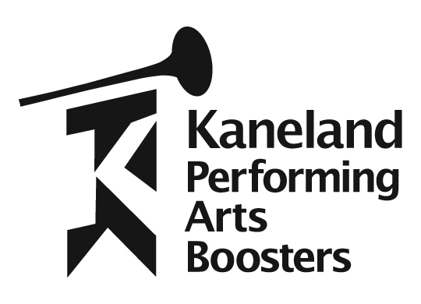
Sixth Annual Knight of Performances

Saturday, March 10, 2018
5:00–8:00 p.m.

Kaneland Harter Middle School
1601 Esker Drive, Sugar Grove, IL

Please join us at the sixth annual Knight of Performances sponsored by the Kaneland Performing Arts Boosters. A variety of talented student musicians and performers from Kaneland Harter Middle School and Kaneland High School will provide entertainment for the evening. Enjoy a delicious dinner from Paisano’s. All proceeds from this event will benefit the students in the band, choir and theatre programs at KHS and KHMS.

To place an order for dinner, please complete this form and return it to your student’s music director in an envelope marked “Knight of Performances Dinner” or mail the form to: Kaneland Performing Arts Boosters, P.O. Box 611, Elburn, IL 60119 no later than Wednesday, February 28th. Last year this event sold out so please return your order forms/payment as soon as possible. A confirmation email will be sent to you within five days of returning this order form. If you do not receive a confirmation, please send an email to: info@knightmusic.org

 | Name: _______________________________ | email address: _________________________
 | Phone: _______________________________
 | My student is performing at the dinner: | Yes No
 | Select your main dish: |  | Quantity Total
- Baked Mostaccioli with marinara sauce w/garden salad and bread |  |  |  | _______ X $10.00 ___________
- Italian Beef Sandwich w/garden salad and chips |  |  |  | _______ X $10.00 ___________
- One slice of pizza w/garden salad Select □ cheese □ sausage □ pepperoni  - Add an extra slice of pizza Select □ cheese □ sausage □ pepperoni  - Kids Meal – one slice of cheese pizza, drink and dessert |  |  |  | _______ X $ 7.00 ___________  _______ X $ 3.00 ___________  _______ X $ 5.00 ___________
One Beverage and one Dessert are included with every meal!
Beverage choices are bottled water and soft drinks.
Additional beverages and/or desserts may be purchased for $1 each.

Total meals ordered: ________________
Total amount enclosed: ______________

Checks made payable to: Kaneland Performing Arts Boosters

Orders due no later than Wednesday, February 28th.
Kaneland Performing Arts Boosters • P.O. Box 611 • Elburn, IL 60119 Like us on Facebook

